DBMS Assignment 1
Contents
Conference Review Database: 2
Assumptions: 2
ERD: 2
Mail Order: 3
Assumptions: 3
ERD: 3

Conference Review Database:

Assumptions:

ERD:
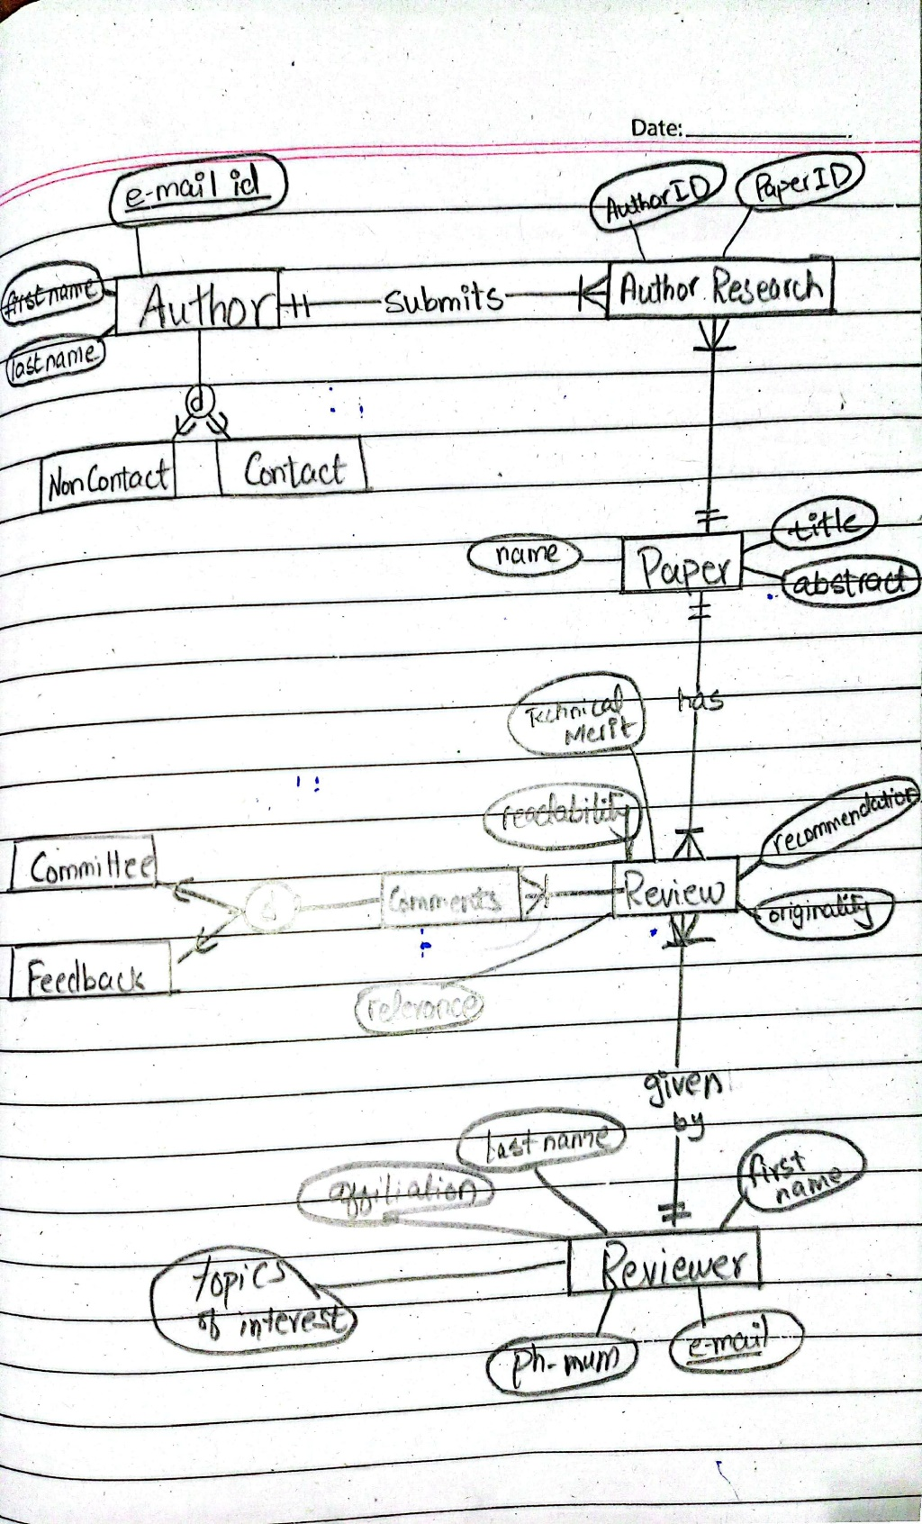

Mail Order:

Assumptions:

ERD:
